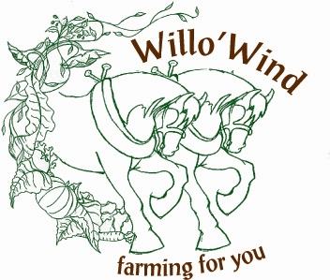
2024/25 Winter CSA Membership Application

10 CSA bins November to May

12740 Concession #5
Uxbridge, Ontario
L9P 1R2

Contacts: Adrian Stocking Address:
Elizabeth Stocking
Phone: (905)852 3878 / (416) 254 0835
Web: www.willowind.ca E-mail: willowindfarm@hotmail.com

Please select from the following: Cost Calculation:
1.Type of share
  - A. Large Share @ $450 1a._____________
  - B. Regular Share @$300 1b._____________
2. Delivery
  - A. Farm pick up 2a._____$0.00___
  - B. Delivery to Toronto + bin fee $75 2b._____________
  - C. Delivery to Uxbridge +bin fee $50 2c._____________
  - D. Discounted group delivery 2d._____________

3. Eggs ____ doz. @ $90 per doz 3. ______________

5. Maple Syrup A. $70. for 250ml bottles 5a.______________
Monthly delivery B. $125. for 500ml 5b.______________ - C. $195 for 1 ltr. bottles 5c.______________

6. Honey A. $185 for ½ kilo bottle 6a. _____________
Monthly delivery B. $115 for 1 1kilo bottle 6b. ____________

7. I would like to make a donation to the Food bank CSA program 7. ______________

Total Owing: $______________

8. Payment Options (please make cheques payable to Willo'Wind Farm)

One full payment Two payments (Second payment due Feb. 1st)

Cheque Cash Online e-transfer

Yes! I’d like to be a CSA member of Willo’Wind!

Name: ___________________________ Mailing Address: _____________________________
Phone: _________________________ _______________________________
E-mail:___________________________ _______________________________

Date:_______________________ Your signature: _____________________

